VR Quidditch

Team members:

Nimrod Goldberger 316169036

Eden Benzimra 209877125

Dan Amoyal 207330317

**General description:**

Game Description:

VR Quidditch is a game that allows the player/s to play as the captain of a Quidditch team.

Quidditch is a fictional sport played by witches and wizards riding flying broomsticks.

Target audience: Harry Potter fans and everyone who enjoys virtual reality games and/or sports games.

Genre: Sports, fantasy, VR

Developed with Unity engine version 2021.3.14f1

**Quidditch overview:**

Matches are played on a large oval pitch with three ring-shaped goals of different heights on each side, between two opposing teams.

There are 3 types of balls in Quidditch:

The Golden Snitch: a small enchanted ball that runs away from the players very fast.

The Bludgers: Two iron balls enchanted to attack players and makes them fall off their broom. These can be stopped using voice commands.

The Quaffle: A big ball that is passed around and fought over in order to score goals.

Each team consists of seven players:

three Chasers, two Beaters, the [Keeper](https://en.wikipedia.org/wiki/Goalkeeper), and the Seeker.

The Keeper defends the goals against the Quaffle.

The Chasers score goals with the Quaffle, each goal is worth 10 points.

The two Beaters [bat](https://en.wikipedia.org/wiki/Bat-and-ball_games) the Bludgers away from their teammates and towards their opponents.

The Seeker locates and catches the Golden Snitch, whose capture simultaneously wins the Seeker's team 150 points and ends the game.

The team with the most points at the end wins.

**Game flow:**

The player is the team’s captain and issues commands to his team and to the Bludgers via voice commands.

The player will have multiple voice commands to which the AI players and Bludgers will react.

Voice commands will be done using the Oculus SDK for Unity.

The goal of each match is to score more points than your opponent.

Points are scored by the team’s Chasers by throwing the Quaffle into the ring-shaped goals (= 10 points) or by the Seeker catching the Golden Snitch (= 150 points).

Catching the snitch ends the game immediately.

The Beaters [bat](https://en.wikipedia.org/wiki/Bat-and-ball_games) the Bludgers to protect their chasers and seeker. They also try to hit the opposing team members with the Bludgers.

The Keeper tries to prevent the Quaffle from entering his team’s ring-shaped goals.

If the snitch hasn’t been caught the game will end after the time limit.

The game can be played by two players simultaneously whom will act as the two team captains.

This multiplayer game will be developed using peer to peer server client.

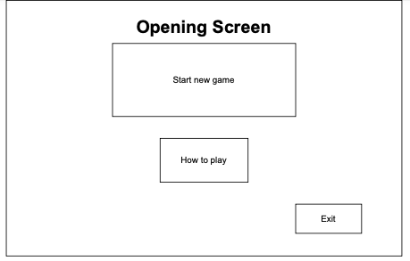1. **Opening screen**:

“Start new game”

“How to play”

“Exit”

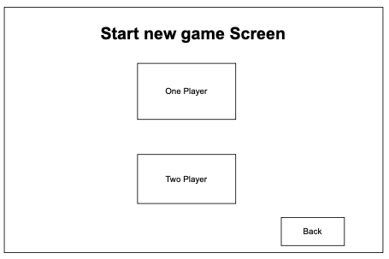2. **“Start new game” screen:**

“One player” - goes to “Choose teams” screen.

“Two players” - goes to “Choose teams” screen.

“Back” – goes back to opening screen.

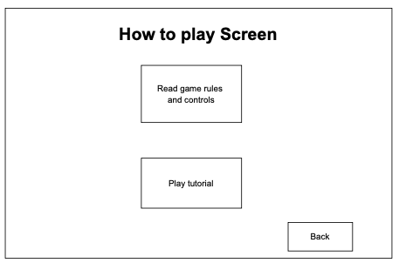

3. **“How to play” screen:**

“Read game rules” – goes to Game rules screen.

“Play tutorial” – goes to Tutorial rules screen.

“Back” – goes back to opening screen.

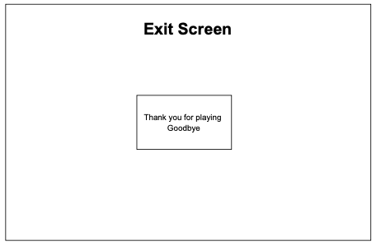

4. **“Exit” screen:**

Closes the game.

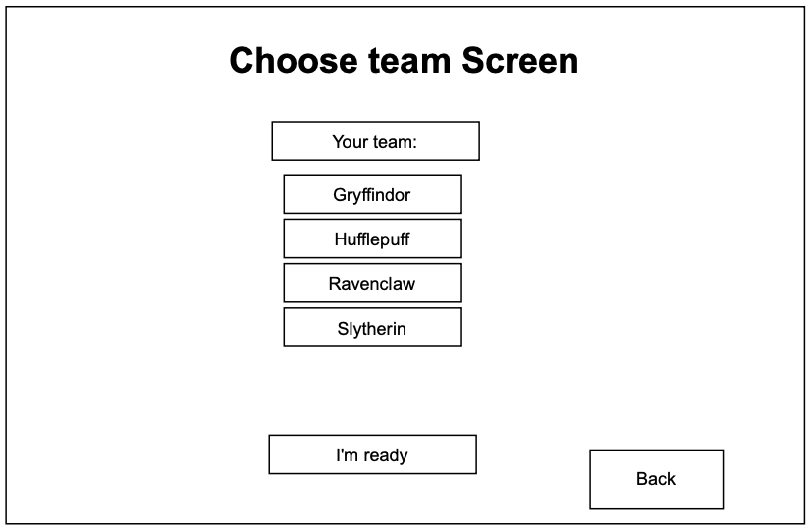5. **“Choose teams” screen**

If there are two players, each one will see this screen.

“Back” – goes back to “Start new game” screen.

Your team:

“Gryffindor”

“Hufflepuff”

“Ravenclaw”

“Slytherin”

“I’m ready”

When ready button is pushed, it goes to Match screen.

In “two players” mode the game waits until both players pushed their “ready” button.

6. **Game rules screen**

The game rules are shown to the player.

“Back” – goes back to “How to play” screen.

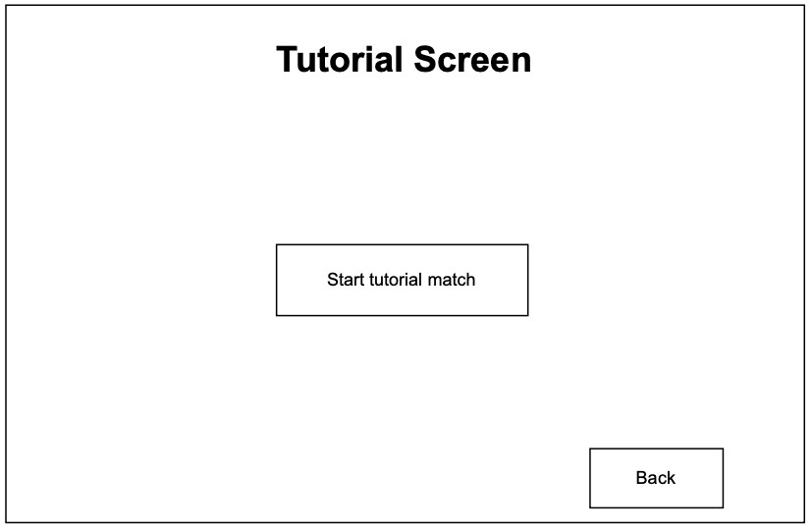

7. **Tutorial screen:**

“Start tutorial match” – goes to Demo match screen.

“Back” – goes back to “How to play” screen.

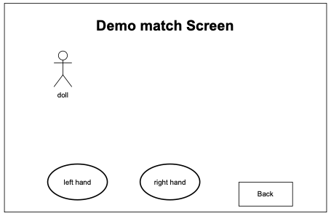

8. **Demo match screen:**

Starts a no time limit demo game with the player, the balls, and fictive opponents.

“Back” – goes back to Tutorial screen.

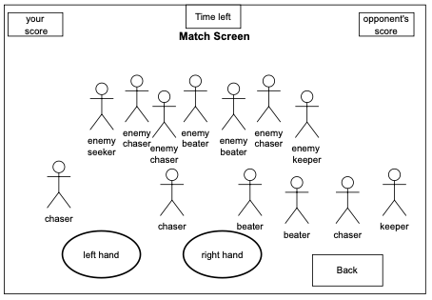9. **Match screen:**

Timer icon – in the middle of the top of the screen

Score icons - on both sides of the timer icon.

Game stadium.

10. **Ending screen:**

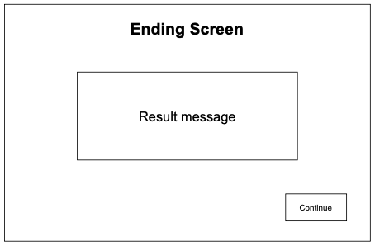

Text congratulating the winning team.

“Continue” – goes back to opening screen.

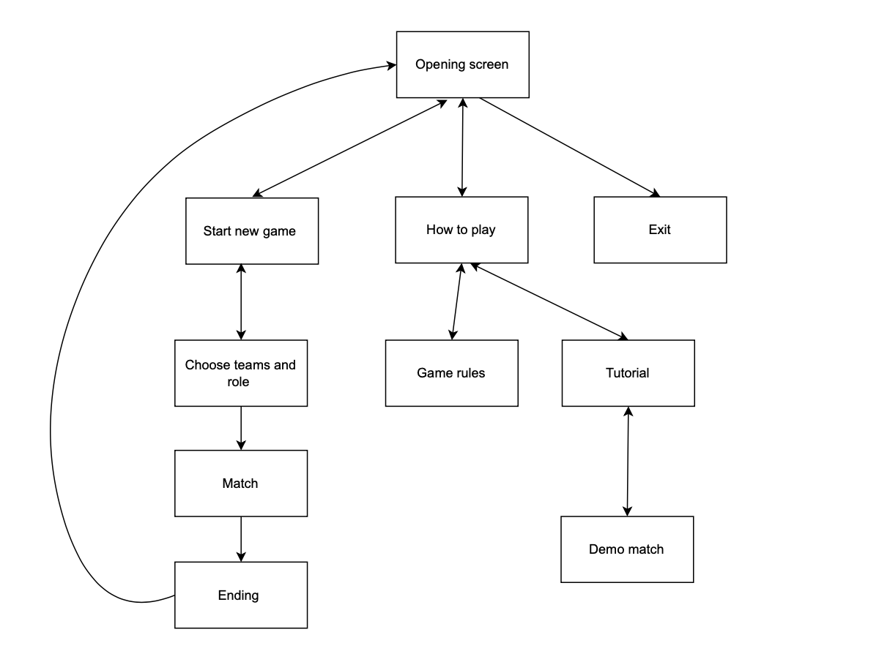

Screens Diagram

**Game controls:**

Left hand:

Controls broomstick fly movement. Has boosts that can be activated using the a button on the left hand. The boosts make the player faster for a brief moment. Each boost is recharged after a cool down.

Right hand:

Catch and throw balls and hit balls with the bat.

Catching: When right hand is within a certain range from the ball it catches it.

Throwing: Pushing a button on the right-hand controller.

Batting: Right hand movement toward the ball.

Voice control:

The player uses voice commands to instruct his team’s npc’s (non playable characters) and to prevent the Bludgers from hitting him.

The commands will be done using the Oculus SDK for Unity.

**AI:**

Chasers try to get close to the ball, if they do they can grab it and will get in position to take a shot at the goals, in which case the player can attempt to block it or let the Keeper try to.

[Keeper](https://en.wikipedia.org/wiki/Goalkeeper)s stick close to the goalposts and defend them, they can intercept incoming balls and pass them to chasers.

Beaters have bats and can hit “Bludgers” (hurtful metal balls) to redirect them at the player or other AI. Getting hit by a Bludger will disable the player momentarily.

When the Bludger get hit by a team it chases members of the opposite team.

The captain (player) can use a number of voice commands to make the other AI members of his team react to various occurrences.

The voice commands include using a spell to stop the Bludgers momentarily to not get hurt, to tell a chaser to catch the ball from the player and tell team member to pass the ball to the captain.

**Multiplayer:**

Multiplayer mode will have duels between 2 players with each acting as the captain of the opposing teams,

issuing commands to their respective AI teammates.

This will be implemented with a peer to peer connection with one player hosting a server and the other player connecting to the host via IP address.

The hosted server will handle all Non Player Character (NPC) and ball calculation/movements while updating the connected client player.

Both the multiplayer and the single player game will occur online.

In order to match the players, we will use random matchmaking using room properties as a filter.

We will set the keys of those properties to be visible from the lobby when creating the room.

Custom room properties are synced to both players in the room and will be useful to keep track of the current map, time left, AI players mode, etc. They are handled as Hashtable with string keys.

By default, to keep things lean, these properties are accessible only inside rooms and are not sent to the Master Server (where lobbies exist).

We will expose some custom room properties in the lobby.

Those properties will be used as filters for random matchmaking and they will be visible in the lobby (sent as part of the room info in the rooms list, only lobbies of default type send rooms lists).